For Immediate Release
The Four Pillars for Your Health, Good Looks and Longevity, a comprehensive book on fruits and vegetables as well as herbs and spices, delights readers
San Jose, California, July 14, 2015—Today Falcon Press International announces the release of Getty Ambau’s new book, The Four Pillars for Your Health, Good Looks and Longevity.
It takes a conscious effort to love and care for yourself. It takes deliberate work to know what is good for your body and to choose foods and drinks that will keep you fit and healthy for years to come. . .
The Four Pillars—referring to vitamins, minerals, herbs and phytonutrients—is written to empower you with nutritional knowledge and help you make appropriate choices, whether it’s buying groceries or looking at a menu in a restaurant. The food and drink recipes have been created to simplify your choices and ensure proper and complete nourishment. Traditionally we have used spices and herbs largely to enhance the flavor and aroma of foods. As you will find in this book, these ingredients can also have tremendous nutritional and health benefits.
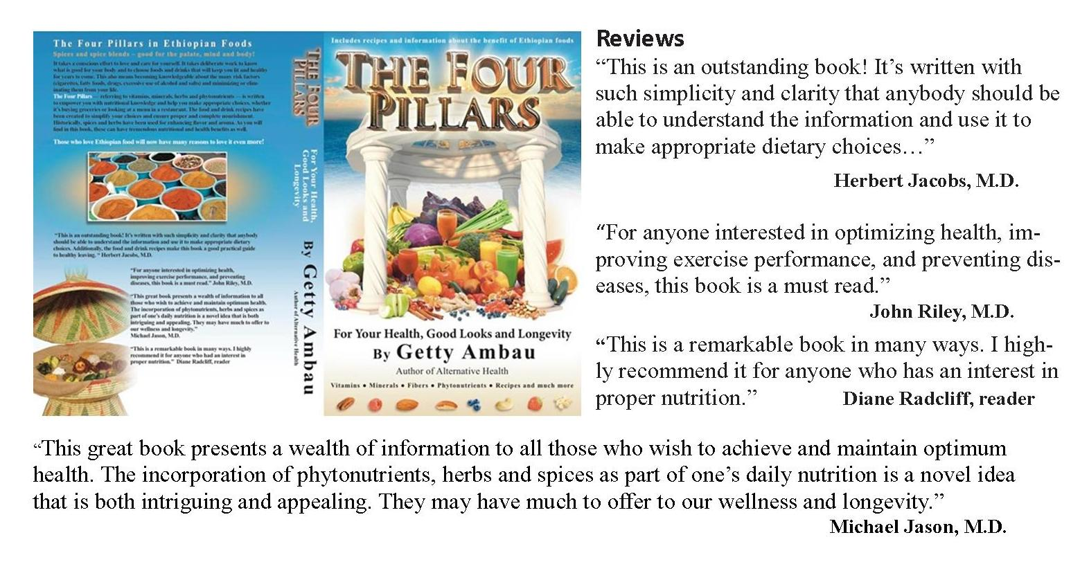
Author Getty Ambau was born in Ethiopia. He first came to the United States as a foreign exchange student, where he studied one year at a high school in Ohio. Later he entered Yale University, where he majored in molecular biophysics and biochemistry and economics. He is the author of two health and nutrition books, which became international bestsellers.
Getty is also the creator of the Desta series (novels), which have received recognition and won three awards.
You may order The Four Pillars at: www.amazon.com, www.barnesandnoble.com and soon at, www.gettyambau.com

