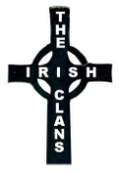
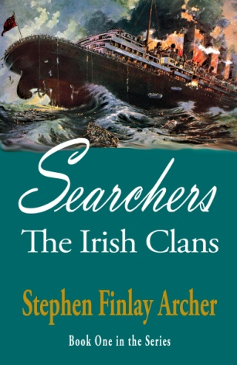
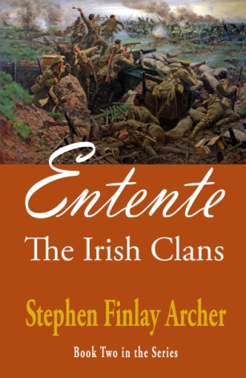

If you enjoyed reading
Searchers: The Irish Clans Book One,
you're gonna love
Entente: The Irish Clans Book Two
Our Irish rebels, in a potential Irish-German entente (alliance) during WWI, move closer to the 1916 Easter Rising. Clues to the mysteries of an ancient Clans Pact are disclosed, and the romantic saga of Tadgh, Morgan, Collin and Kathy heats up.
Please join Steve for his book launching and signing at Greenhorn Creek Golf Club
Friday, June 16 from 5:30 to 7:00 pm
Fireside Room
Manzanita Writers Press is tickled “green” to host a special event to meet author Stephen Finlay Archer. His second in the five-book series of The Irish Clans, Entente, is now available. In the spirit of The da Vinci Code, his books are adventure romance novels set in 20th century history.
This year marks the centennial of U.S. entry into WWI, which tipped the scales to defeat the Central Axis powers. What events caused us to abandon our nationalistic policy to help liberate Europe, and how did they relate to the potential Irish-German entente and Ireland's fight for freedom? Come and hear what Steve has to say about this momentous decision.
Steve will sign copies at this event. Iced tea, lemonade, adult beverages and light snacks will be provided. Publication of his third novel in the series, Rising, is due by year-end. Come join the discussion! Everyone is welcome, Irish or otherwise.

